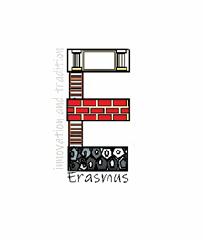

My dream job in the middle ages is
Lady-in- Waiting

I would like to be a lady-in-waiting because it seems like a good job to be the best friend of a queen or princess.
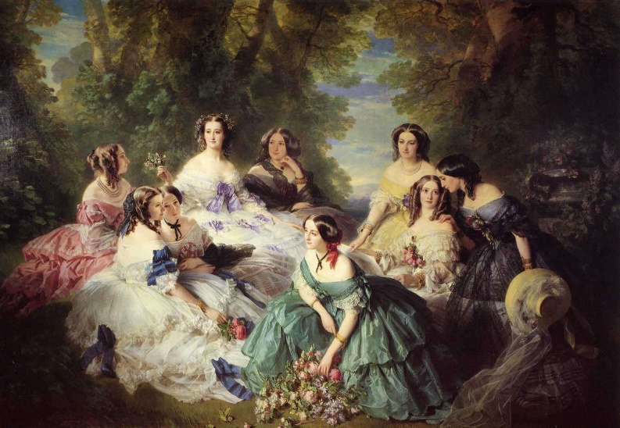
Take care of the princes
from an early age.
Performing by her side
all her life And with
other ladies-in -waiting.
A position at the court
would provide me with for the most part a fixed salary.
I couldn't leave the castle for a short while,but I wouldn't mind.
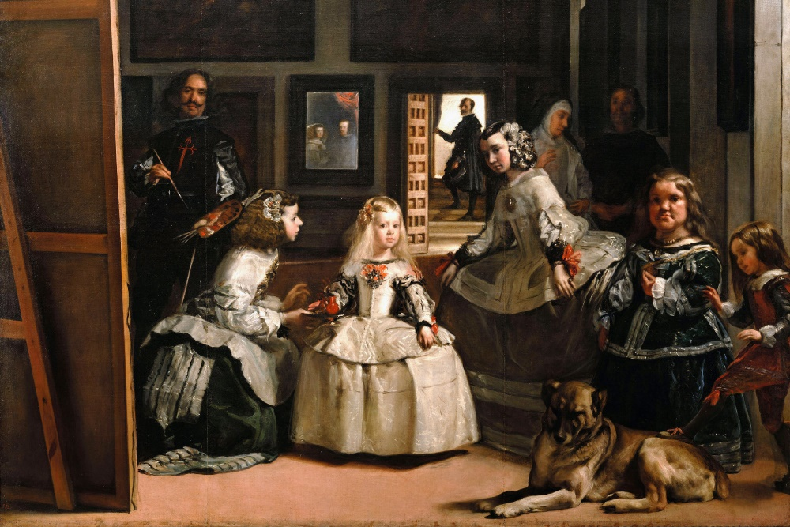

"The European Commission support for the production of this publication does not constitute an endorsement of the contents which reflects the views only of the authors, and the Commission cannot be held responsible for any use which may be made of the information contained therein."

