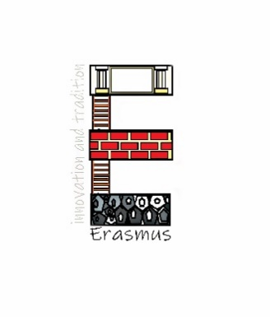
"The European Commission support for the production of this publication does not constitute an endorsement of the contents which reflects the views only of the authors, and the Commission cannot be held responsible for any use which may be made of the information contained therein."

THE ROLE OF CRAFTS IN THE SOCIETY IN THE PAST

- Brainstorming – what traditional crafts can you name- make a list:

- Choose 1 traditional craft and create a mind map:

- Discussion – what role crafts had in the past and why is it important to encourage crafts and arts nowadays

- Prepare a crossword for one chosen traditional craft:

